https://www.dynapar.com/technology/encoder_basics/quadrature_encoder/

**What is a quadrature encoder?**

A quadrature encoder is an incremental encoder with 2 out-of-phase output channels used in many general automation applications where sensing the direction of movement is required. Each channel provides a specific number of equally spaced pulses per revolution (PPR) and the direction of motion is detected by the phase relationship of one channel leading or trailing the other channel.

**How does a Quadrature Encoder work?**

The code disk inside a quadrature encoder contains two tracks usually denoted Channel A and Channel B. These tracks or channels are coded ninety electrical degrees out of phase, as indicated in the image below, and this is the key design element that will provide the quadrature encoder its functionality. In applications where direction sensing is required, a controller can determine direction of movement based on the phase relationship between Channels A and B. As illustrated in the example optical encoder figure below, when the encoder is rotating in a clockwise direction its signal will show Channel A leading Channel B, and the reverse will happen when the quadrature encoder rotates counterclockwise.

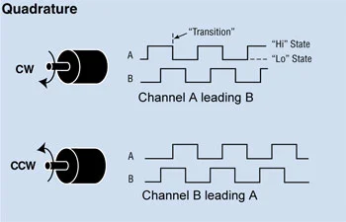

Apart from direction, position can also be monitored with a quadrature encoder by producing another signal known as the “marker”, “index” or “Z channel”. This Z signal, produced once per complete revolution of the quadrature encoder, is often used to locate a specific position during a 360° revolution.

**Achieving higher resolution with Quadrature Encoders**

When more resolution is needed, it is possible for the counter to count the leading and trailing edges of the quadrature encoder’s pulse train from one channel, which doubles (x2) the number of pulses per revolution. Counting both leading and trailing edges of both channels (A and B channels) of a quadrature encoder will quadruple (x4) the number of pulses per revolution. This technique is known as encoder and will depend on how the signal is decoded through the users drive, PLC or Controller.

As a result, 10,000 pulses per turn can be generated from a 2,500 PPR quadrature encoder. Typically with a Dynapar encoder, this 4x signal will be accurate to better than ±1 count. Likewise, 40,000 pulses can be generated from a 10,000 PPR quadrature encoder.

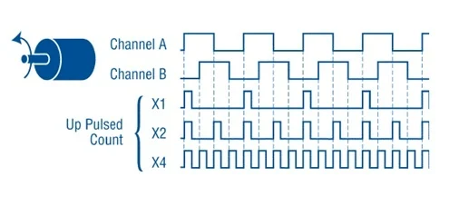

By triggering on the rising and falling edges of the pulse train, we can double or quadruple the counts per revolution from the same quadrature encoder disc.

This technique can be an effective way to increase resolution without changing the code disc. However, it requires a well-behaved square wave output for effective detection. Care should be taken with choice of output driver; particularly over long cable runs or in noisy environments. The accuracy of the quadrature encoder output should also be taken into account as this will also be multiplied by the encoding factor.

**How to use**

https://cdn.sparkfun.com/datasheets/Robotics/How%20to%20use%20a%20quadrature%20encoder.pdf

**The Basics of Encoder Selection**

FEBRUARY 1, 2017 | MOTION CONTROL

<https://www.techbriefs.com/component/content/article/tb/supplements/md/features/articles/26431>

The characteristic parameter of an incremental encoder is the number of rectangular pulses per motor revolution. Typically, there are two channels delivering the same pulse number. The two signals have a relative phase shift of one quarter of a pulse length. This arrangement allows the detection of the direction of motor rotation and gives four distinct states per pulse. Sometimes these states are called quadcounts. They represent the real resolution, which is four times higher than the number of pulses on one channel (Figure 1). An encoder with 1,000 CPT (counts or pulses per turn) gives 4,000 states per turn, or a nominal resolution of 360°/4000 = 0.09°.

Encoder resolution spans a wide range from a very simple 1 CPT (or 4 states) encoder that can be used simply to detect motion, up to several 10,000 CPT for highly accurate position or speed feedback. There are many factors that influence resolution, including the underlying physical principle (optical, magnetic, inductive), the primary signal type (analog or digital), the signal treatment (e.g. interpolation), and the mechanical layout.

<https://www.motioncontrolonline.org/content-detail.cfm/Motion-Control-News/How-to-Select-the-Right-Encoder-for-Your-Motion-Axis/content_id/3155>

In a quadrature encoder, the code disc incorporates at least two channels, the A channel and the B channel. The two are patterned 90° out of phase. This returns two signals that are 90° out of phase electrically (in quadrature). As a result, channel A goes high first, enabling the system to detect direction of motion (see Figure 4).

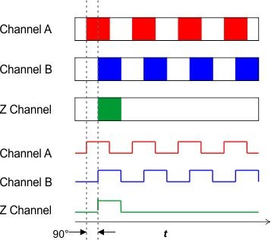

There are three formats typically used. Triggering off of the rising edge of channel A (1X decoding) provides a resolution equal to the PPR of the code disc (see Figure 7). Triggering off of the rising and falling edges of channel A (2X decoding) provides the actual resolution of twice the PPR. Triggering off the rising and falling edges of both channel A and channel B (4X decoding) gives a resolution quadruple that of the PPR. Depending on the application, it may be a good way to boost resolution with minimum additional cost. “You should consider the flexibility that you have, knowing that you can use a multiplier of 1X, 2X, or 4X to increase resolution through software implementation versus having to either buy new components or to purchase a new encoder with a higher PPR,” says Dalsen Ferbert, applications engineer at Dynapar (Gurnee, Illinois).

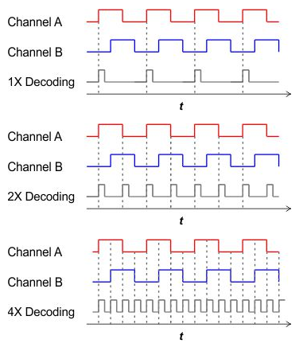

That said, the approach involves trade-offs. For OEMs confident of the resolution they need, a higher actual resolution rather than one generated through software may be less prone to error. “Using interpolated pulse counts by counting the leading and trailing edges can work generally but it is important to be conscious of the quality of the square wave edges,” says Ferbert. “If you have longer cable runs, let's say 50 feet or more and you don't have the proper line driver, the signal edges are going to become less and less pronounced.” There are techniques that can be used to reduce noise over long cable runs. This involves properly specifying the output driver to screen out noise, which is a topic we will cover next.